Workshop: Using Visualization in Teaching Introductory E&M
AAPT National Summer Meeting, Edmonton, Alberta, Canada.
Organizers: John Belcher, Peter Dourmashkin, Carolann Koleci, Sahana Murthy

Faraday’s Law Supplementary Materials

Visualizations

You can find more visualizations at Faraday Law Visualizations. We highlighted two of the visualizations below that complement the workshop activity.

Magnet falling Through a Ring with Zero Resistance show an example of Faraday's Law, as a magnet is dropped through a conducting ring. As the magnet falls under gravity, a current is induced in the ring that tries to keep the magnetic flux through the area of the ring constant. This corresponds to a field that produces a force that opposes the motion of the magnet: as it approaches from above, the induced current generates a field that pushes the magnet upwards. Once it falls through the ring, the direction of the current changes to produce a field that tries to pull the magnet upwards. In this case, since the ring has zero resistance, the flux through it remains constant. This is evidenced by the fact that the fieldlines from the magnet never cross the ring. However, the magnet is still heavy enough that it falls through.
The first animation shows the magnetic field configuration around a magnet as it falls. The current in the ring is indicated by the small moving spheres. The motions of the field lines are in the direction of the local Poynting flux vector.
The second animation shows a three-dimensional fieldline representation of the same thing.

Faraday's Law Applet Part 2 . This visualization illustrates the electromagnetic interaction between a conducting non-magnetic ring and constant external magnetic field. Adjusting the ring's radius and rotation, or the magnitude of the external field, causes the magnetic flux through the ring to change. This change gives rise to a current in the ring which is in a direction such as to oppose the change in flux, as described by Lenz's Law. If the resistance of the ring is zero, the change in induced flux in the ring will exactly counter the change in external flux due to the external field, thus keeping the total flux constant. Increasing the resistance hinders the flow of induced current, resulting in a delay in the response of the ring to the change in external flux, and a corresponding change in total flux. This can be seen in the flux graph as you manipulate the parameters.

ConcepTests

The following ConcepTests illustrate various aspects of Faraday’s Law. They can be used both in class and on exams.

Wire loop in an Increasing Magnetic Field

The magnetic field through a wire loop is pointed upwards and increasing with time. The induced current in the coil is

- clockwise as seen from the above.
- counterclockwise as seen from the above.
- zero.
- not sure.
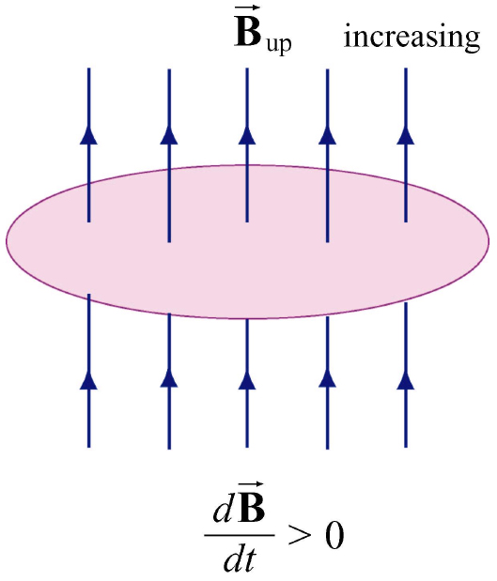

Answer: 1. Current is clockwise as seen from above looking down. This direction will produce an “induced” B field generated by the current in the coil that points downward over the area of the wire loop. This “induced” B field is trying to offset the increasing external magnetic field through the wire loop. (Lenz’s Law—the system reacts to try to keep things the same). Note we are ignoring the effects of self induction.

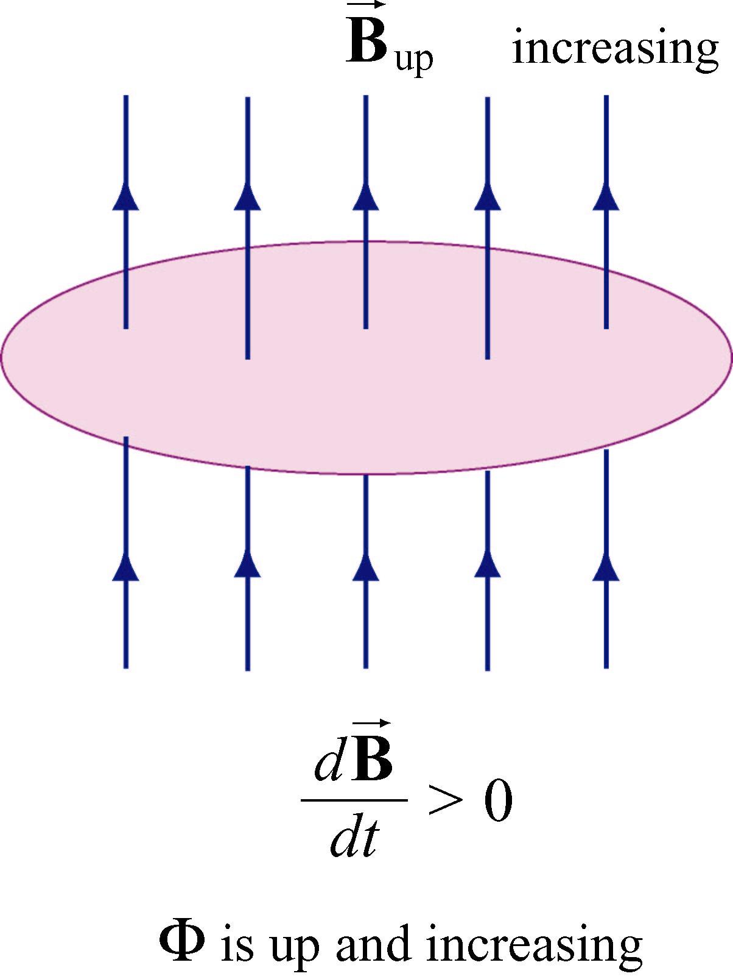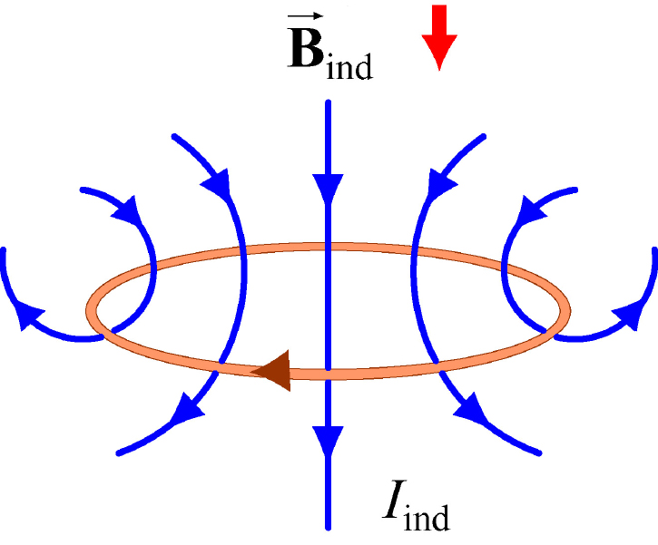

Wire Loop in a Decreasing Magnetic Field

The magnetic field through a circular wire wire loop is pointed upwards and decreasing with time. The induced current in the coil is

- clockwise as seen from the above.
- counterclockwise as seen from the above.
- zero.
- not sure.

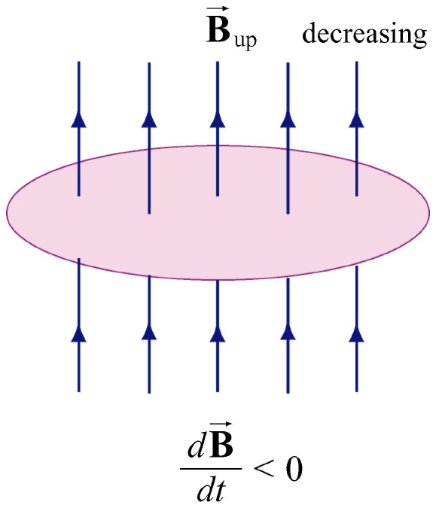

Answer: 2. The current is counterclockwise as seen from above. This direction will produce an “induced” B field generated by the current in the coil that points upward over the area of the wire loop. This “induced” B field is trying to offset the decreasing magnetic field upwards through the wire loop. (Lenz’s Law—the system reacts to try to keep things the same). Note we are ignoring the effects of self induction.

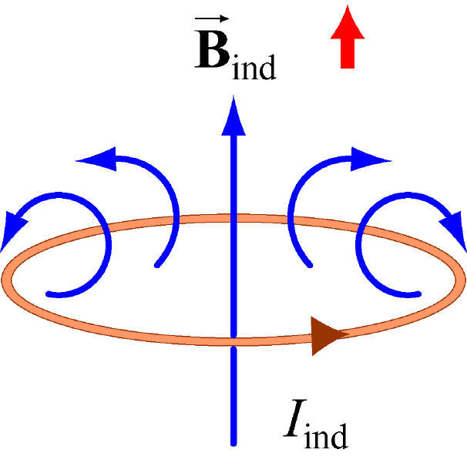

Current and Force on a Wire Loop Moving Through a Changing Magnetic Field A wire loop moves up from underneath a magnet with its north pole pointing upward. Which of the following choices best describes the current in the wire loop as seen from above and the force on the wire loop?

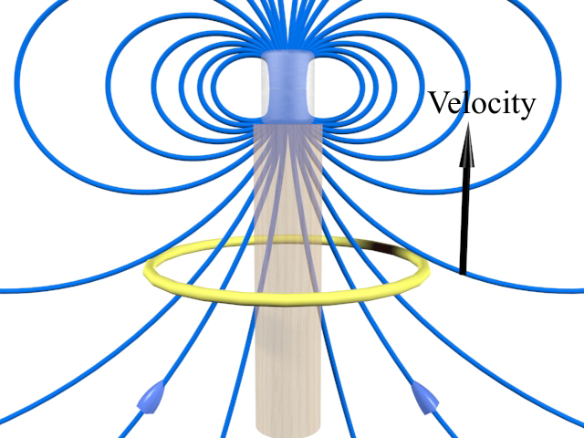

- Current clockwise and force up.
- Current counterclockwise and force u p.
- Current clockwise and force down.
- Current counterclockwise and down.
- Not sure.
Answer: 3. The current is clockwise as seen from above and the force is down

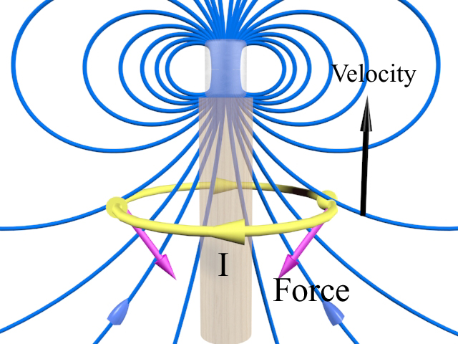

The clockwise current implies a self-field of the current in the wire loop that is downward, trying to offset the increase of magnetic flux upwards through the wire loop as it moves upward into a stronger external magnetic field 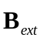 originating from the magnet (Lenz’s Law). The 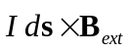 force on the wire loop is a force which is trying to keep the flux through the wire loop from increasing by slowing it down (Lenz’s Law again).
Force on a Wire Loop Moving Through a Changing Magnetic Field A wire loop is below a magnet and moving downwards. The magnet has its north pole pointing upward. The force on the wire loop is

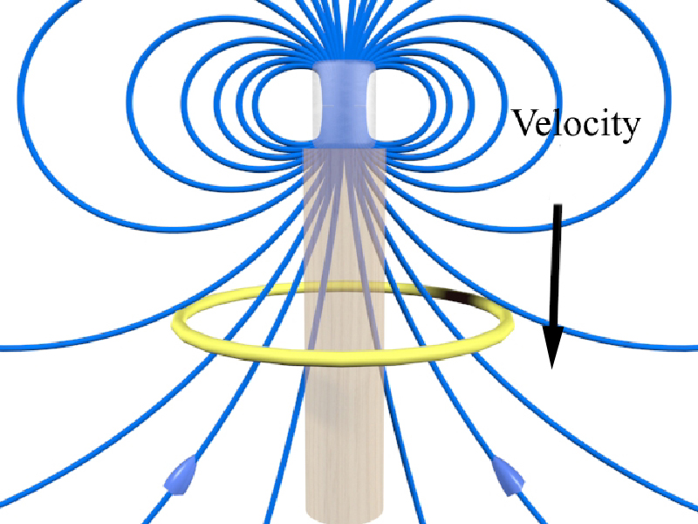

- upwards.
- downwards.
- zero.
- not sure.

Answer: 1. Upwards.

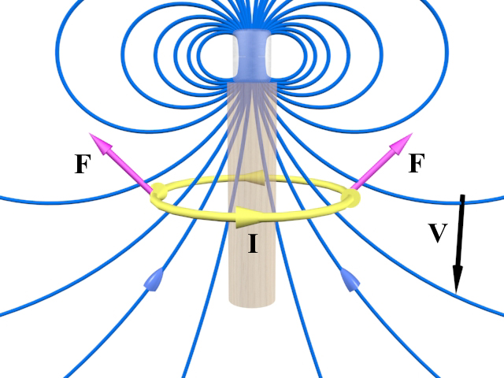

The current in the wire loop flows in the counterclockwise direction as seen from above. The induced magnetic field from the current in the wire loop points upwards is opposing the change of magnetic field of the magnet (decreasing upwards) through the wire loop as the wire loop moves downwards. The force is upwards, as shown. That is, the force is trying to keep the wire loop from moving downwards, and thus trying to keep the flux through the wire loop from increasing. This is an example of Lenz’s Law—the response of the system to changes is to try to keep things the same, in this case to stop the wire loop from moving to regions of lower external magnetic field strength. The current loop also acts as a magnetic dipole pointing upward, and hence it is attracted to the magnet which is also a dipole pointing upwards since two aligned dipoles attract.

Traditional Analytic Problems:

Problem: Moving Wire loop Near Current Carrying Wire

A rectangular wire loop of dimensions l and w moves with a constant velocity away from an infinitely long straight wire carrying a current I in the plane of the wire loop, as shown in the figure. The total resistance of the wire loop is R.

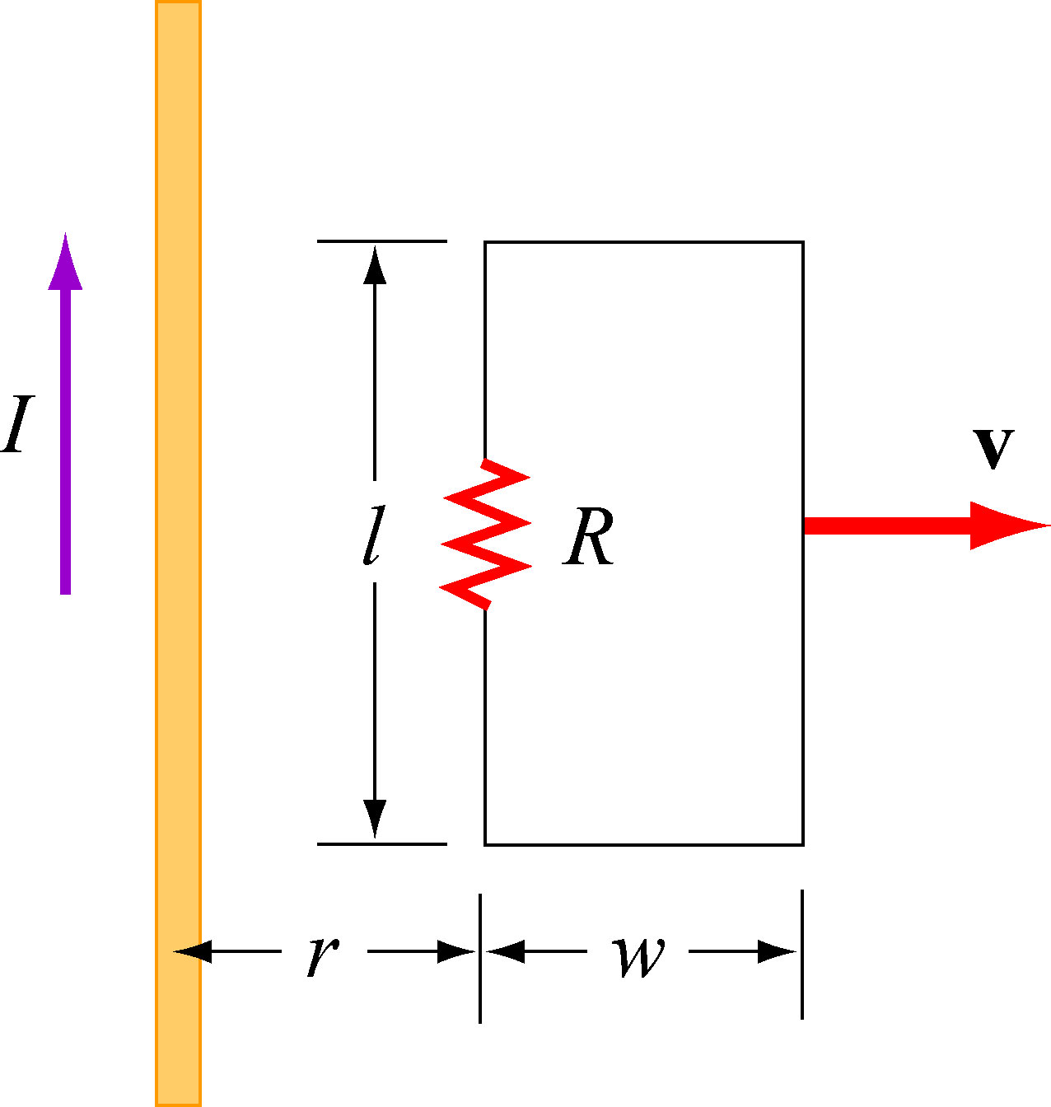

(a) Using Ampere’s law, find the magnetic field at a distance s away from the straight current-carrying wire.

Solution: Consider a circle of radius s centered on the current-carrying wire. Then around this Amperian loop, 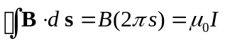
which gives
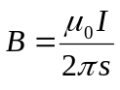 (into the page)

(b) What is the magnetic flux through the rectangular wire loop at the instant when the lower side with length is at a distance r away from the straight current-carrying wire, as shown in the figure?
Solution: 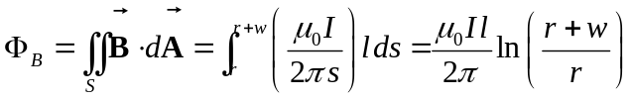 (into the page)

(c) At the instant the lower side is a distance r from the wire, find the induced emf and the corresponding induced current in the rectangular wire loop. Which direction does the induced current flow?

Solution: The induce emf is
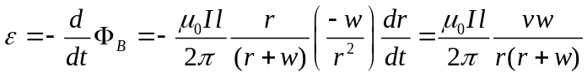

The induced current is
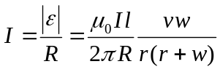
The flux into the page is decreasing as the wire loop moves away because the field is growing weaker. By Lenz’s law, the induced current produces magnetic fields which tend to oppose the change in magnetic flux. Therefore, the current flows clockwise, which produces a self-flux that is positive into the page.

Problem: Alternating-Current Generator

An N-turn rectangular wire coil of length a and width b is rotated at a frequency in a uniform magnetic field  which points into the page, as shown in the figure below. At time t = 0, the wire coil is vertical as shown in the sketch, and it rotates counterclockwise when viewed along the axis of rotation from the left.

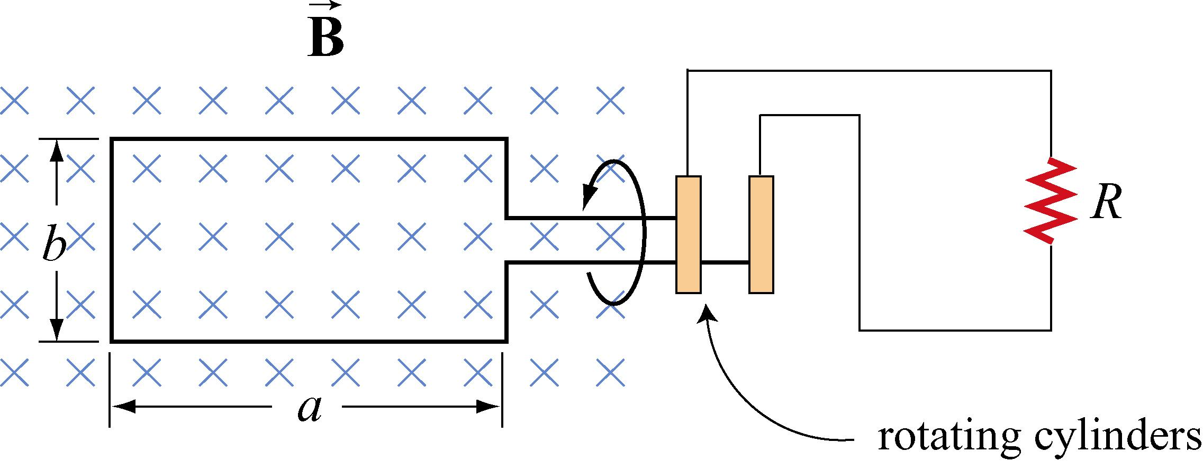

(a) Make a sketch depicting this “generator” as viewed from the left along the axis of rotation at a time  shortly after t = 0, when it has rotated an angle θ from the vertical. Show clearly the vector , the plane of the wire coil, and the direction of the induced current.

Solution:
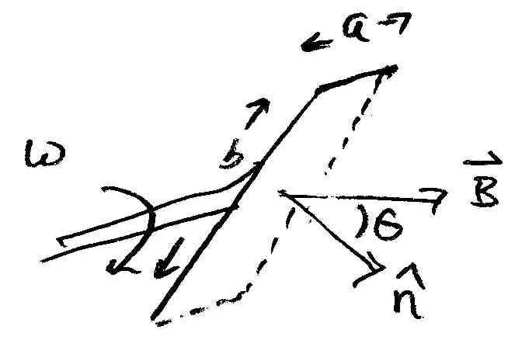

(b) Write an expression for the magnetic flux 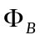 passing through the coil as a function of time for the given parameters.

Solution: The dot product between the magnetic field and the unit normal is

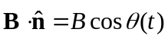
.

The angle 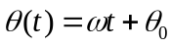 where is the angular frequency is related to the frequency by 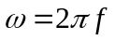, and 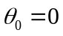 is the angle between and and 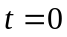. The magnetic flux through the coil is

(c) Show that an induced emf 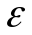 appears in the coil, given by

Solution: The time derivative of the magnetic flux is

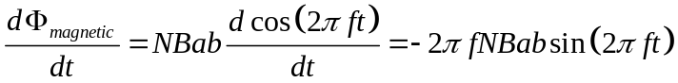

So there is a non-zero electromotive force in the wire coil.

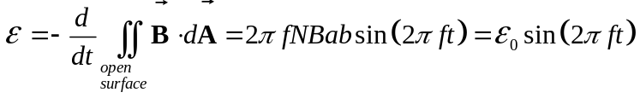

where 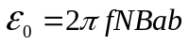.

(d) Design a coil that will produce an emf with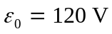when rotated at 60 revolutions/sec in a magnetic field of 0.40 T. (Describe the dimensions of the coil and the number of wrappings.)

Solution: At first we may want to minimize the length of the wire that we need. Suppose we have a square loop of side . The total length of the wire with  turns is 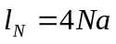. If we choose a single square loop of side 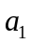, then the length of a single loop is 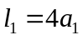. Since we want 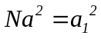. We have that 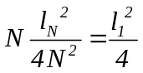. This implies that the length of the coil with turns is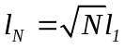. The length increases as a function of the 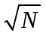. So to minimize costs we choose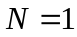. Since the electromotive force 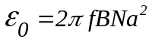, the length of a side is

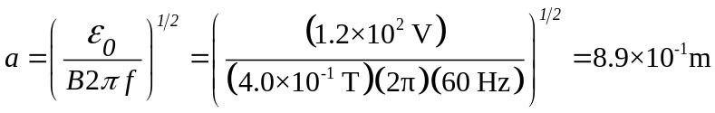
.

This is a pretty big loop, 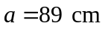.
Context Rich Problems

Designing a Kitchen Mixer

Design a stand mixer (something like a Kitchenaid stand mixer), or, more accurately, the motor for one.

a) This DC motor needs to have a reasonable torque and run at a reasonable frequency. Estimate these values, recalling that they are also related to the power of the motor, which you should also estimate (feel free to use the web page to get a handle on these values)

Solution: Just thinking about it, the rotation rate of mixers probably ranges from 1 Hz to 10 Hz. Numbers from mixer companies typically range from 50 rpm to 300 rpm (~1 Hz to ~ 5 Hz). I’ll work with an angular frequency of ω = 10 s⁻¹.

The torque is harder to think about. A blade radius is about 5 cm, but how much force can it push with? From experience I know it is a decently hard push with my hand, which is probably about 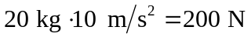 meaning a torque of about 10 N m. We can also get an estimate of the torque by thinking about the power (just like 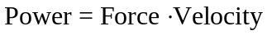 we have 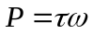). Since the motor power of stand mixers is around 300-500 Watts, for ω = 10 s⁻¹, we get a torque of about 30 N m. Of course this is an overestimate because some of the power is not going into usable work (torque) but it’s in line with our other estimate, and after some work we can get a feeling of how much of an overestimate it is.

b) Think about the details of a DC motor for a minute. How much torque do you get on average (or at max, if that is easier) in terms of the dimensions of the coil, the strength of the permanent magnet and the amount of current & number of turns in the coil? You need to estimate the first two of these values and will calculate the last two knowing what the torque is.

Solution: The motor will be a coil of radius a and N turns. With current I it will have a magnetic moment of 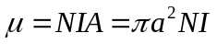. Let’s put the entire coil in a B field B from a permanent magnet. If not aligned it will feel a torque
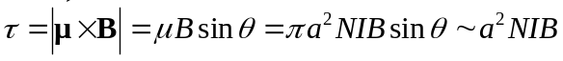.
where in the last step I just get rid of the angular dependence because I don’t want to think about it. This then is the maximum torque – the average (or more accurately rms) will be smaller by a factor of 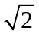 which is negligible in these approximation problems.

We can estimate the field strength (B ~ 0.1 T) and the radius of the coil (a ~ 1 cm).
With these numbers I have an estimate

The power from the wall is AC, and AC motors work just fine but we are using a DC motor to run our mixer. So you will want to use an AC/DC converter in your blender. You can easily buy these that go from wall power to just about any voltage you want (with low voltages near 3 V and high voltages near 500 V being a common range). You can assume the converter is ideal and that output power can be as high as input power.

c) As the motor coil rotates, something else happens (which is the whole reason I put this problem on this assignment). What happens? Note that because of this the current when running won’t actually be constant using a simple DC drive. You should pretend that it is constant to make your life easier.

Solution: As the coil rotates it will also feel a back EMF because the flux through the loop changes in time (it acts like a generator!) Let’s think about it pictorially first:
B
I
In this position the flux is up and decreasing. So a CCW EMF, opposing the current, is induced.
In this position the flux is up and increasing. So a CW EMF, opposing the current, is induced.
This EMF is going to vary in time, but we can just use the average value by finding the total change in flux per half period and divide by the half period. Roughly a half period is shown above, where you can see that the change in flux is twice the maximum flux (it was max in one direction, then in the other). So the average EMF is:
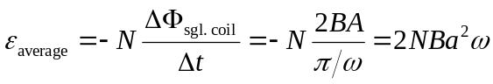
Keep in mind that the EMF always opposes the “battery,” (in this case the power supply) so the total voltage is reduced from the supply voltage V.

Since the flux oscillates, the flux change oscillates and the EMF and current will oscillate as well, which is the meaning of the last comment. We’ll just assume a constant average EMF and hence constant average current.

d) OK, you are almost there. Our coil is made of copper wire (which has a resistivity of 1.7 μΩ cm, a density of 9000 kg/m³, a specific heat of 0.4 J/g K and a melting point of 1350 K). The resistance of the coil depends on the diameter of the wire and its length (the number of turns). To choose the wire diameter (which you need to do carefully so that the wire doesn’t melt when you push a lot of current through it) you can consult a table like the one at http://www.powerstream.com/Wire_Size.htm, Of course, you can’t know how much current there is until you know how many turns there are (see part b), and you can’t know how many turns you should use until you know how much resistance you can afford (in terms of power dissipation) and how large the coil is going to end up being (which depends on wire diameter), so at this point would have to just pick a value and run with it and see if the results are reasonable. I’ll suggest that you use a wire radius of 0.5 mm. Now figure out the details: the number of turns, the current and the DC voltage you need.

Solution: We can calculate the current knowing the resistance of the wire:
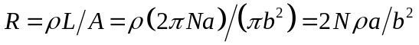
where b is the radius of the wire. With b = 0.5 mm, the chart indicates we can handle a current of about I = 2 A. I use the smaller number (power transmission) because this is in a coil so heating is more detrimental, but this is probably a conservative number for the amount of current we can deal with.

With I now fixed we can calculate N from the above value for NI:
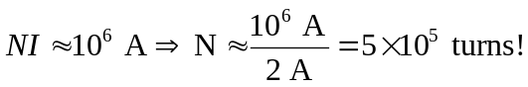
We can also calculate resistance and EMF (and thus the voltage):

Although those numbers seem a little big, it’s the power loss due to resistive heating that really concerns me:
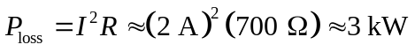
So, that’s bad. There is ten times as much wasted power as usable power. We can increase N (and hence R) and decrease I (and hence P, since it goes like I²). But N is already enormous and if you stop to think about the physical size of the coil it’s just ridiculous.

e) You may or may not be happy with the numbers you have come up with at this point (please let us know if you are or not). If you aren’t one thing you can consider to fix the issue is mechanical gears (do they put trannies in mixers?). As you change the gear ratio (which tells how fast the output turns relative to the motor), what changes? Which way would you want to gear it (should the motor turn faster or slower than the mixer blade)? Is there any reason not to push the gear ratio to some extremely large value?

Solution: Definitely we need to decrease the torque of the motor which is going to let us turn down our NI factor (both the current and the number of turns in the coil). That can make resistive heating go away as a problem. To do this the rate of rotation ω of the motor must increase as τ decreases. We can’t push this to a huge gear ratio though because as ω increases so does the back EMF. More importantly, the fraction of the supplied voltage that goes to overcoming the back EMF is going to increase . This isn’t inherently bad, but it means that if we have a jam, where the mixer blade (and then the motor) stops rotating, the back EMF will disappear and suddenly there will be a HUGE current surge, which will lead to the lovely aroma of burning wiring.

Of course, the transmission also helps address this problem. Typically things are designed so that if the blade gets stuck the transmission slips rather than stopping the motor from rotating. Another feature (which you will see on the professional kitchenaid mixers where people make a lot of bread which tends to be bad for this kind of thing) is strong surge protection. If the back EMF disappears the current will increase and blow the fuse in the mixer, hopefully before burning the wiring.

Superconducting Magnets

Frequently to make strong, uniform magnetic fields a superconducting solenoid is used. Once current is “loaded” into the solenoid, the two ends can be tied together and then the current will continue to circulate forever. Calculate the total energy stored (when fully charged) and the inductance in the following two magnets:

a) The strongest constant field laboratory magnets currently available create a field of 45 T with a current of 150 A. They have a bore diameter of 5 cm and an active length (where the field is basically uniform) of about 10 cm.

Solution: We can get the energy from the field strength and volume, then use that to calculate the inductance:
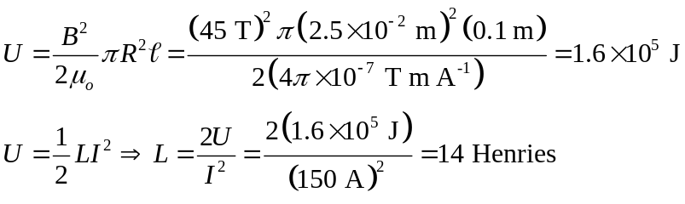

b) A standard MRI magnet is 2 m long, 0.75 m in diameter and has a field strength of 2 T.
In designing MRI magnets, people work very hard to make the field uniform throughout
the core of the magnet (that is to say, it’s not just a straight solenoid). Let’s assume its
just an ideal solenoid (it’s not – they work very hard to get a uniform field by arranging
additional coils just in the right places). If it takes 100 A to make the 2 T field, what is the energy stored and the inductance of the solenoid?
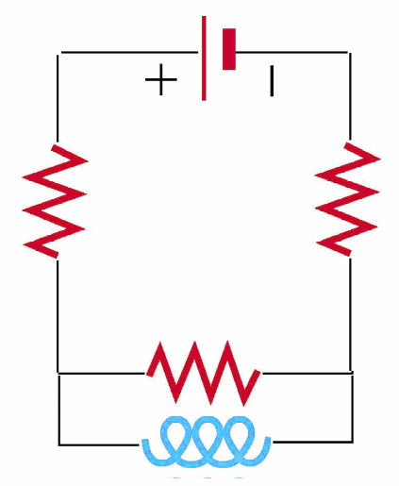
Solution: Again, we can get the energy from the field strength and volume:

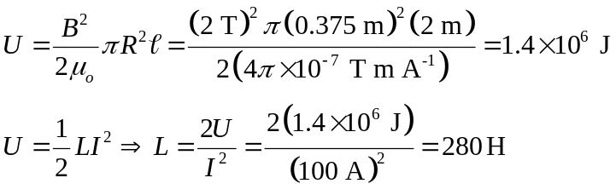

The magnet is superconducting, so is charged using the method pictured at right. A battery ε is used to drive current through leads (resistance R_{L} = 0.5 Ω on each lead) down into the solenoid (inductance L). All of the wires below the two leads (the resistors), including the coil, are superconducting, except for a small piece of wire connected in parallel with the coil, which is heated above its superconducting transition temperature to give it a resistance R_{PCS} = 10 Ω (PCS stands for persistent current switch).

Although I’ve drawn a battery, we really use a current supply to “charge” (or energize) the magnet, which can theoretically supply whatever voltage is necessary to get you the current you want. The current is slowly ramped upward until it reaches its desired value. Why slowly? Because as you change the current the inductor puts up a fight and you don’t want it to fight too much, because as it does it dissipates power in the PCS resistor. Since the whole magnet is surrounded by liquid helium some of that Helium will be boiled off by that heat. A rule of thumb is that 1 Watt burns 1 liter of liquid helium in one hour.

c) If you only want to burn 30 liters of helium while charging the magnet, how long does it take to energize it?

Solution:
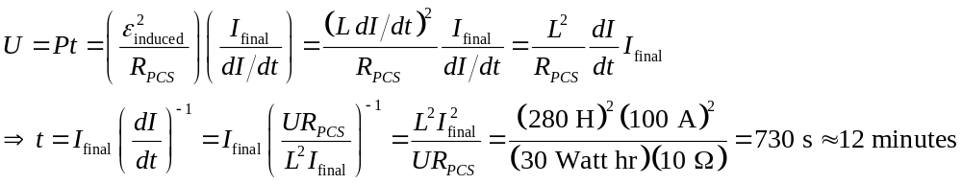
Once the final current is reached the heater on the PCS is turned off and the resistance falls to zero. The current supply is then ramped down, and the current in magnet runs through this now zero resistance PCS wire. Since the entire loop is superconducting the current will remain constant in that loop forever (as long as you keep it cold!)

Occasionally faults happen though (someone brings a magnetic material into the room like a stretcher or gas cylinder) and it gets sucked into the magnet, jarring it and causing part of the magnet to become normal (non-superconducting). This is called a quench.

d) If at t = 0 s a 1 kΩ resistance suddenly appeared in the bottom loop write an equation for the current as a function of time after this point.

Solution: 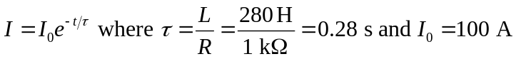

e) Assume that the magnet is in a container of 1000 liters of liquid helium (this is probably an overestimate, but it is a big magnet). How much of this helium is boiled by the quench? How rapidly?

Solution: Almost all of the energy in the magnet is going to come out in about 1 second (3 time constants means current is down by e³ ~ 30 so energy is down by 30² ~ 1000. The total energy in the system was 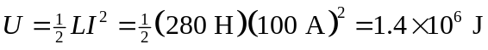 which can burn
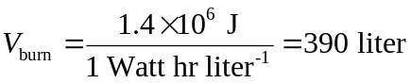

f) When helium goes from liquid to gas it expands by a factor of 750. Assuming that the container was at 1 atmosphere and basically full before the quench, what is the pressure after the quench? How much force does this pressure exert on the inner wall of the MRI (i.e. in towards the patient)? Should they worry?

Solution: Well, 390 liters suddenly wants to become 750 * 390 liters = 3 x 10⁵ liters. Of course it can’t, the volume stays about the same so the pressure instead shoots up by 750, to about 750 atmospheres. This is big. One atmosphere is ~ 15 psi or 10⁵ Pascals (the SI unit of pressure). So the pressure is 7.5 x 10⁷ Pascals and the force is:
This is a large enough force to crush a 10” thick steel casing of this diameter. The patient should be very worried.
Of course, in real life smart engineers designed some blow off valves into the system so in the event of a quench (which does happen) the gas is very quickly removed from the system and the pressure doesn’t build up to nearly this level.
Quenches also happen in laboratory magnets. We typically have 50 liters of He, not 1000 liters, but when it all boils it fills the room with very cold helium gas which is exciting but difficult to breath in so you need to be careful when working with high field He cooled magnets.

